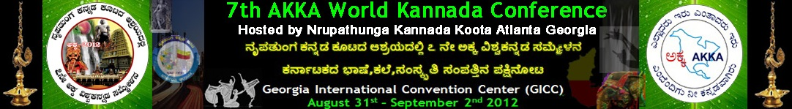


ಸಾಹಿತ್ಯ ಪ್ರಪಂಚ
AKKA Literary Programs 2012
ನಮಸ್ಕಾರ!

We cordially invite you all to enjoy and participate in the various programs we have planned for you. Please select from the following options.

- Each participant must fill one form
- Each participant may select more than option, if so preferred.
- Please email the completed form to akkawkc2012literary@googlegroups.com. The deadline for form submission is April 30, 2012.

Kavana-Gaayana: A fun competition for those who love to write poems and also for singers who can sing for the same. Participants will come as a team and recite their poem and sing the poem in a nice musical tune. Best performers will win attractive prizes.

Pustaka parichaya: This is your chance to shine!! If you have authored a book, grab your chance to release your book at the splendid 7th AKKA convention. You can be rest assured that your book will reach ardent Kannada readers across the US, India and the world. Please send in your Book details, few lines about you.

MakkaLa sahitya: ಇಂದಿನ ಮಕ್ಕಳೇ ಮುಂದಿನ ಪ್ರಜೆಗಳು ಎಂಬ ಮಾತು ನಮಗೆಲ್ಲ ತಿಳಿದಿರುವ ವಿಷಯ. There are many literary personalities such as J.P. Rajarathnam who have contributed tremendously to children's literature, enriching our childhood and lives. In honor of these literary icons, we present to you, a fun filled quiz program, JEOPARDY For KIDS. If you would like to enter your children into the contest, please fill out this form now and let your kids showcase their knowledge!

Debate: Come alone or come in a group and make it a fun filled, fierce and friendly debate session. Register now to participate. If you are part of a group, please send us your title and the list of all participants. Please note that all participants must be registrants of the AKKA WKC 2012 convention.

JEOPARDY For ADULTS: We have added this quiz program for adults based on Kannada literature. Enroll now Tell us what you know and win some prizes along the way!!

Don't have time to prepare for the above events?? No problem. There are many more opportunities to have fun and win prizes on the spot too.

Padabanda competition
Guess the portrait
Guess the song
Enact on a topic and many more.

For any further information please contact Vanishree Rao at akkawkc2012literary@googlegroups.com.

Contact Info

Chair
Vanishree Rao: vrao_92@hotmail.com

